**Chapter 6**

**Vector Calculus**

**6.7 Stokes’ Theorem**

**Section Exercises**

**For the following exercises, without using Stokes’ theorem, calculate directly both the flux of  over the given surface and the circulation integral around its boundary, assuming all are oriented clockwise.**

327.  *S* is hemisphere 

Answer: 

329.  *S* is upper hemisphere 

Answer: 

331.  *S* is a portion of paraboloid  and is above the *xy*-plane.

Answer: 

**For the following exercises, use Stokes’ theorem to evaluate  for the vector fields and surface.**

333.  and *C* is the intersection of paraboloid  and plane  and using the outward normal vector.

Answer: 

335. Use Stokes’ theorem to evaluate  where *C* is the curve given by  traversed in the direction of increasing *t*.

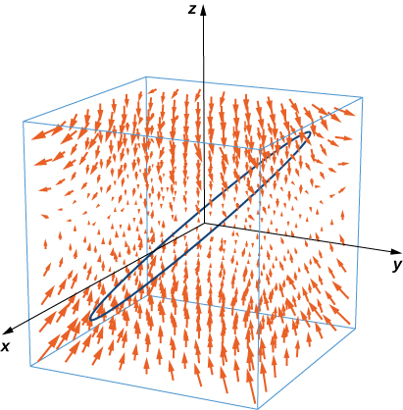

Answer: 

337. **[T]** Use a CAS and Stokes’ theorem to approximate line integral  where *C* is the intersection of the *xy*-plane and hemisphere  traversed counterclockwise viewed from the top—that is, from the positive *z*-axis toward the *xy*-plane.

Answer: 

339. Use Stokes’ theorem to evaluate  where  and *S* is half of sphere  oriented out toward the positive *x*-axis.

Answer: 

341. **[T]** Use a CAS and Stokes’ theorem to evaluate  where  and *S* consists of the top and the four sides but not the bottomof the cube with vertices  oriented outward.

Answer: 

343. Use Stokes’ theorem to evaluate , where  and *S* is a triangle with vertices (1, 0, 0), (0, 1, 0) and (0, 0, 1) with counterclockwise orientation.

Answer: 

345. Use Stokes’ theorem to evaluate  where *C* is the curve of intersection of plane  and ellipsoid  oriented clockwise from the origin.

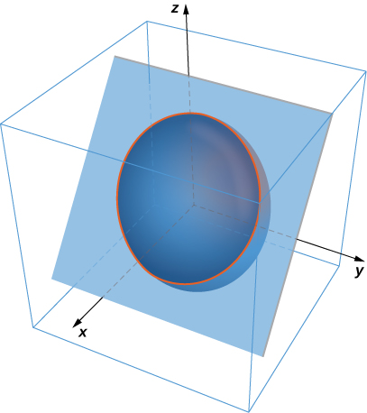

Answer: 

347. Use Stokes’ theorem for vector field  where *S* is surface  *C* is boundary circle  and *S* is oriented in the positive *z*-direction.

Answer: 

349. A certain closed path *C* in plane  is known to project onto unit circle  in the *xy*-plane. Let *c* be a constant and let  Use Stokes’ theorem to evaluate .

Answer: 

351. Let *S* be hemisphere  with , oriented upward. Let  be a vector field. Use Stokes’ theorem to evaluate 

Answer: 

353. Use Stokes’ theorem to evaluate , where  and *C* is a triangle with vertices (0, 0, 0), (2, 0, 0) and  oriented counterclockwise when viewed from above.

Answer: 

355. Use Stokes’ theorem to compute  where  and *S* is a part of plane  inside cylinder  and oriented counterclockwise.

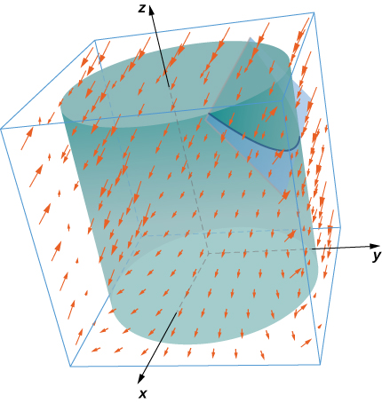

Answer: 

357. Let  and let *C* be the intersection of plane  and cylinder  which is oriented counterclockwise when viewed from the top. Compute the line integral of **F** over *C* using Stokes’ theorem.

Answer: 

359. Let *S* be ellipsoid  oriented counterclockwise and let **F** be a vector field with component functions that have continuous partial derivatives.

Answer: 

361. **[T]** Use a CAS and Stokes’ theorem to evaluate  if  where *C* is the curve given by 

Answer: 

363. **[T]** Use a CAS to evaluate  where  and ***S*** is the surface parametrically by  

Answer: 

**For the following application exercises, the goal is to evaluate**

**where  and *S* is the upper half of ellipsoid**



365. Evaluate a surface integral over a more convenient surface to find the value of *A*.

Answer: 

367. Take paraboloid  for  and slice it with plane  Let *S* be the surface that remains for , including the planar surface in the *xz*-plane. Let *C* be the semicircle and line segment that bounded the cap of *S* in plane  with counterclockwise orientation. Let  Evaluate

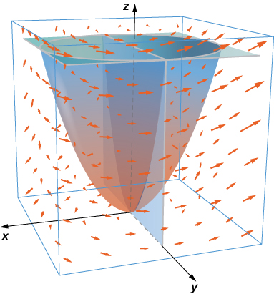

Answer: 

**For the following exercises, let *S* be the disk enclosed by curve for  where  is a fixed angle.**

369. What is the circulation of *C* of vector field  as a function of 

Answer: 

371. Circle *C* in plane  has radius 4 and center (2, 3, 3). Evaluate  for  where *C* has a counterclockwise orientation when viewed from above.

Answer: 

373. Evaluate integral where and *S* is the cap of paraboloid  above plane , and **n** points in the positive *z*-direction on *S*.

Answer: 

**For the following exercises, use Stokes’ theorem to find the circulation of the following vector fields around any smooth, simple closed curve C.**

375. 

Answer: 0

This file is copyright 2016, Rice University. All Rights Reserved.